- Create VPC
- Create Internet gateway
- Create Custom Route Table
- Create Subnet
- Associate subnet with Route Table
- Create Security Group to allow port 22.80,443
- Create a network interface with an ip in the subnet that was created in step 4
- Assign an elastic IP to the network interface created in step 7
- Create Ubuntu server and install/enable apache2

1. Set up environment
- Make sure you have installed:
  - Terraform
  - terraform -version
  - AWS CLI
  - aws configure
Enter your AWS Access Key, Secret Key, and set region us-east-1.

2. Open project in VS Code
- Open VS Code
- Create a new folder, e.g. terraform
- Inside it, create a file main.tf
- Write the terraform script inside main.tf as per the requirements.

3. Update the script
In aws_instance block, replace:
key_name = "your-keypair-name"
➡️ Use your actual AWS Key Pair name (from AWS EC2 → Key Pairs section).
Make sure you also have the .pem file downloaded if you want SSH access.
main.tf:
provider "aws" {
region = "us-east-1"
}
# 1. Create VPC
resource "aws_vpc" "custom_vpc" {
cidr_block = "10.0.0.0/16"
enable_dns_support = true
enable_dns_hostnames = true
tags = {
Name = "custom-vpc"
}
}
# 2. Create Internet Gateway
resource "aws_internet_gateway" "igw" {
vpc_id = aws_vpc.custom_vpc.id
tags = {
Name = "custom-vpc-igw"
}
}
# 3. Create Custom Route Table
resource "aws_route_table" "public_rt" {
vpc_id = aws_vpc.custom_vpc.id
route {
cidr_block = "0.0.0.0/0"
gateway_id = aws_internet_gateway.igw.id
}

tags = {
Name = "public-rt"
}
}
# 4. Create Subnet
resource "aws_subnet" "public_subnet" {
vpc_id = aws_vpc.custom_vpc.id
cidr_block = "10.0.1.0/24"
map_public_ip_on_launch = false # we'll attach EIP manually
availability_zone = "us-east-1a"
tags = {
Name = "public-subnet"
}
}
# 5. Associate Subnet with Route Table
resource "aws_route_table_association" "public_assoc" {
subnet_id = aws_subnet.public_subnet.id
route_table_id = aws_route_table.public_rt.id
}
# 6. Create Security Group to allow ports 22, 80, 443
resource "aws_security_group" "web_sg" {
name = "web-sg"
description = "Allow SSH, HTTP, and HTTPS"
vpc_id = aws_vpc.custom_vpc.id
ingress {
from_port = 22
to_port = 22
protocol = "tcp"
cidr_blocks = ["0.0.0.0/0"]
}
ingress {
from_port = 80
to_port = 80
protocol = "tcp"
cidr_blocks = ["0.0.0.0/0"]
}
ingress {
from_port = 443
to_port = 443
protocol = "tcp"
cidr_blocks = ["0.0.0.0/0"]
}
egress {
from_port = 0
to_port = 0
protocol = "-1"
cidr_blocks = ["0.0.0.0/0"]
}
tags = {
Name = "web-sg"
}
}
# 7. Create Network Interface in the subnet
resource "aws_network_interface" "web_eni" {
subnet_id = aws_subnet.public_subnet.id
private_ips = ["10.0.1.10"]
security_groups = [aws_security_group.web_sg.id]
tags = {
Name = "web-eni"
}
}
# 8. Assign Elastic IP to the Network Interface
resource "aws_eip" "web_eip" {
domain = "vpc"
network_interface = aws_network_interface.web_eni.id
associate_with_private_ip = "10.0.1.10"
depends_on = [
aws_instance.web_server, # wait until EC2 is created
aws_internet_gateway.igw # wait until IGW is ready
]
tags = {
Name = "web-eip"
}
}
# 9. Create Ubuntu Server and Install Apache2
resource "aws_instance" "web_server" {
ami = "ami-08c40ec9ead489470" # Ubuntu 22.04 LTS in us-east-1 (check latest before use)
instance_type = "t2.micro"
key_name = "your-keypair-name" # <-- replace with your existing keypair
network_interface {
network_interface_id = aws_network_interface.web_eni.id
device_index = 0
}
user_data = <<-EOF
#!/bin/bash
apt-get update -y
apt-get install -y apache2
systemctl enable apache2
systemctl start apache2
EOF
tags = {
Name = "ubuntu-apache-server"
}
}

4. Initialize Terraform in VS Code Terminal
Open VS Code terminal (Ctrl + ~) and run:
terraform init

5. Apply configuration
terraform apply
This will build:
- VPC, Subnet, IGW, Route Table
- Security Group
- ENI + Elastic IP
- Ubuntu EC2 instance with Apache2
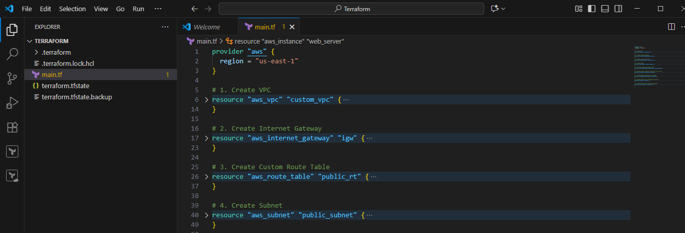
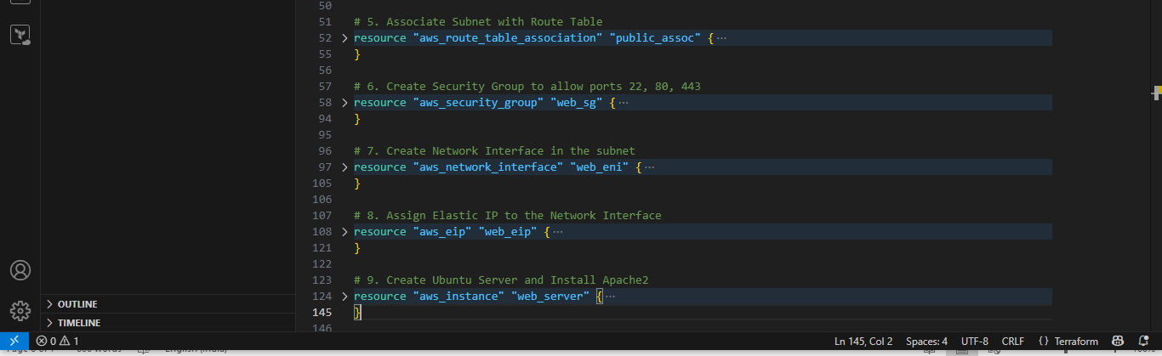

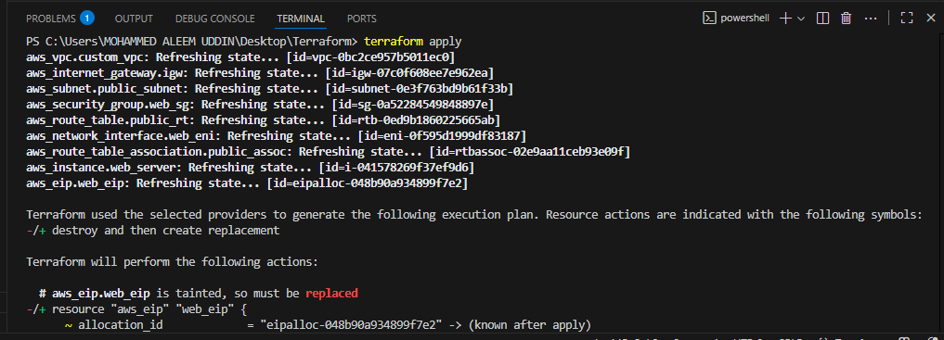
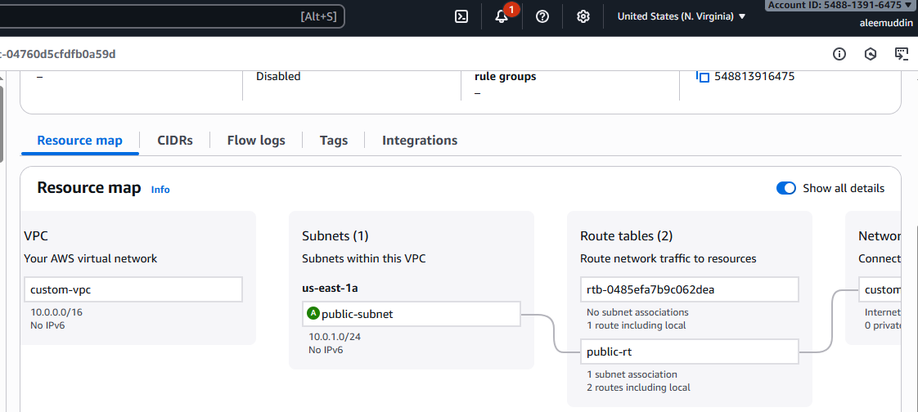
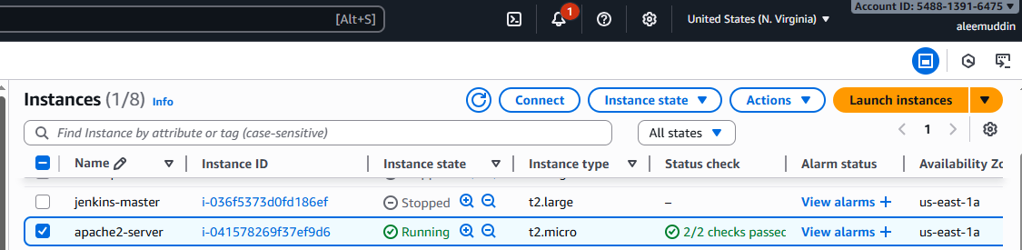
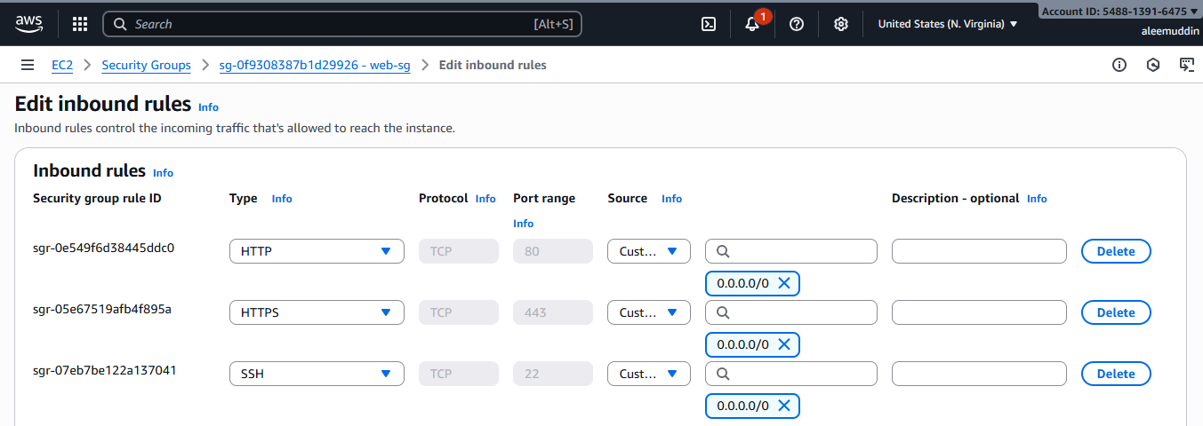
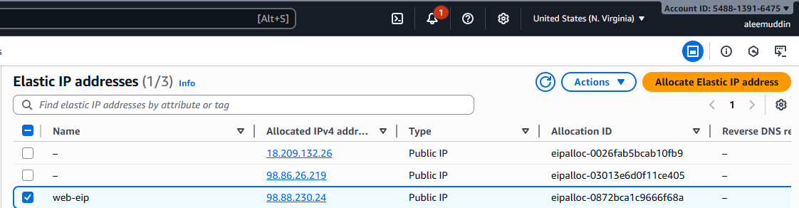

6. Test Apache in Browser
Copy the public IP and open:
http:// 98.88.230.24
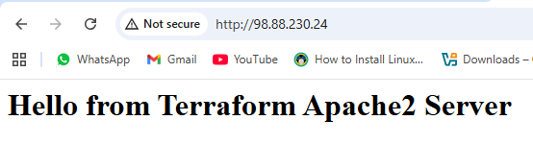

✅ You should see the Apache default welcome page.

7. Cleanup when finished
To delete all resources:
terraform destroy

